AEC & NS simulation result

By ZhengChen

Table of Contents

Change Log
Version | Description | Author | Date
0 | Initial version | Z.C | 17／7／11

Case 1: SNR = 0dB, echo tail length = 128ms

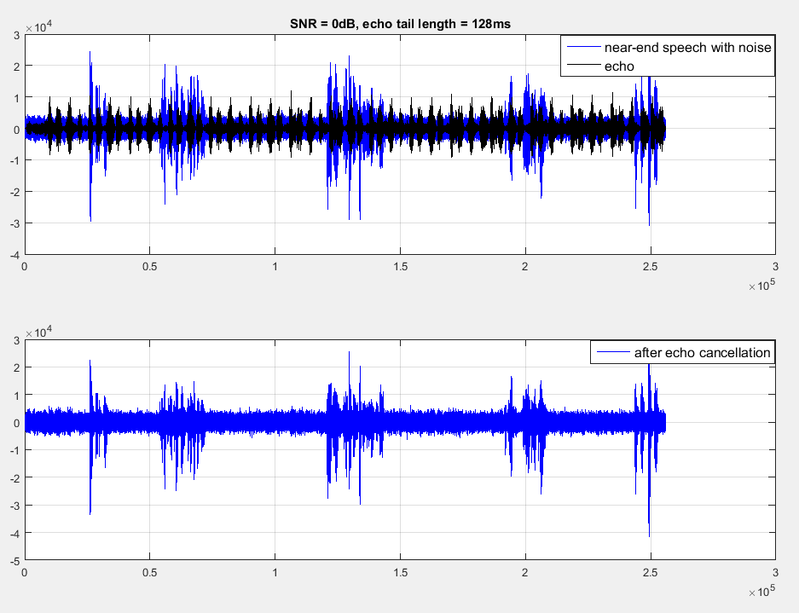
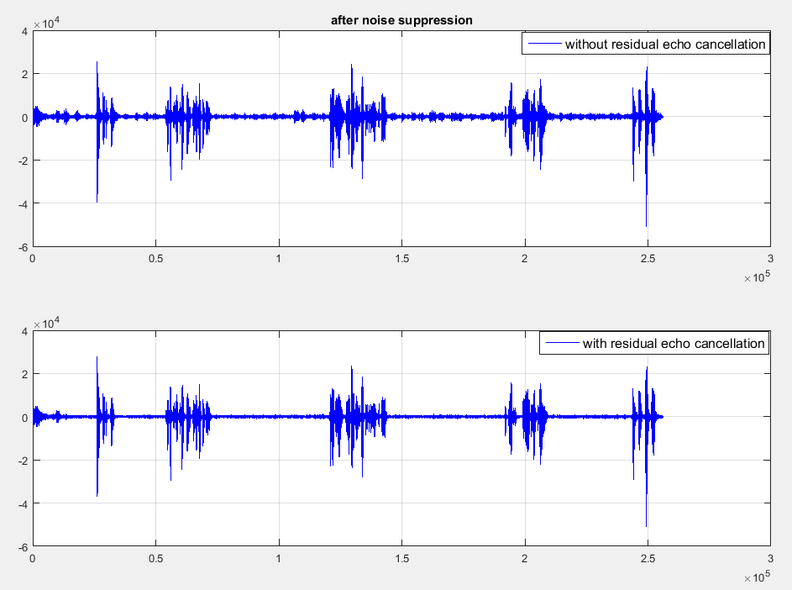

Case 2: SNR = 10dB, echo tail length = 128ms

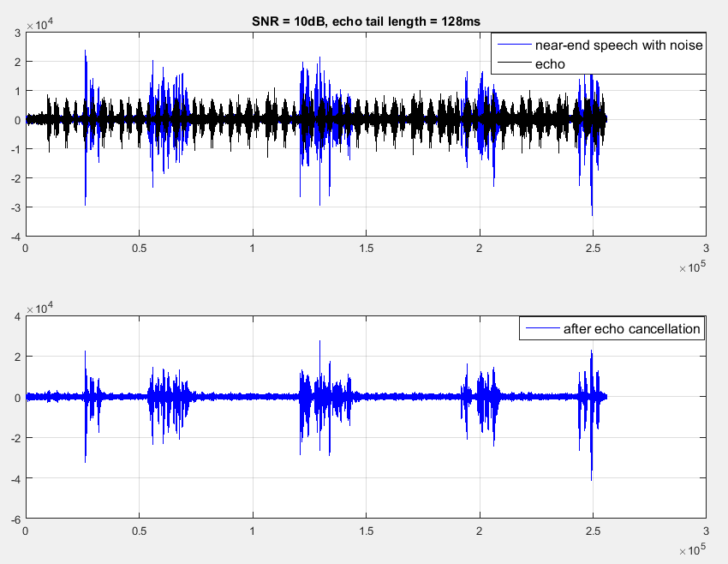
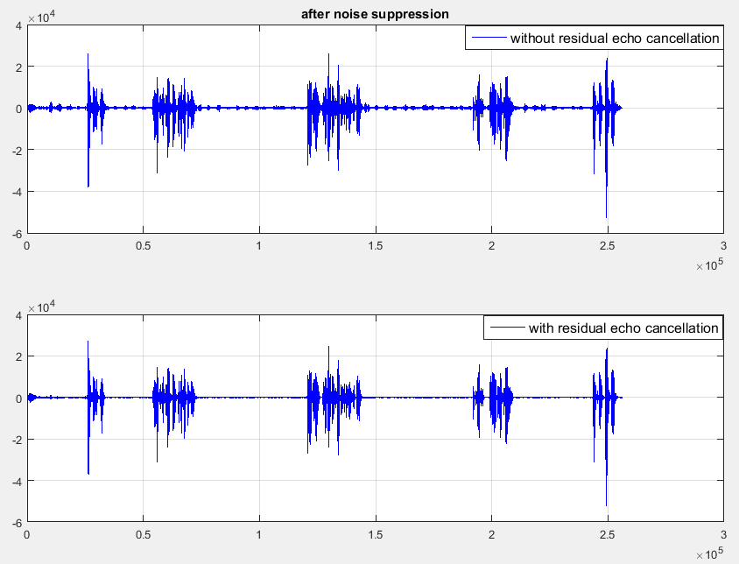
Case 3: performance with/without pre-emphasis filter

